**Research Question:**

Participants were recruited to play Family Feud with research assistants. They were told to compete for the high score by guessing the most common words related to a category word. See below for example … they would not see the words until they got them correct:

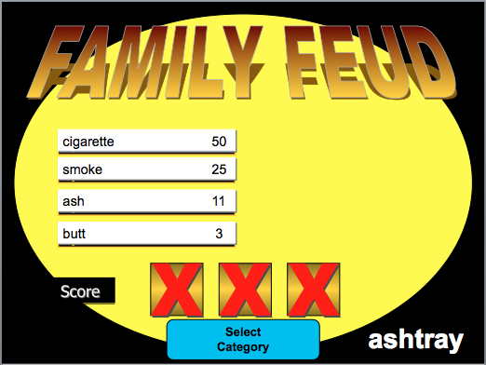

**Between Subjects IV(s):**

* Group: Different types of Family Feud were given to participants
  + Without numbers: traditional Family Feud without the scores they would receive for getting it right
  + With numbers: Family Feud modified to show participants the scores they would receive if they got them right
* Helpers:
  + Singles: participants worked alone
  + Doubles: participants worked in pairs

**Repeated Measures IV(s):**

* Forward: Strength of relationship between words that you would normally be guessing in family feud (i.e. ashtray to cigarette)
  + Levels: High, Medium, Low (first part of variables H_, M_, L_)
* Backwards: strength of reverse relationship (i.e. cigarette to ashtray)
  + Levels: High, Medium, Low (last part of variables H, M, L)

**Between Subjects DV:**

* Total Score: participants final score in the family feud game, higher scores indicate they did better (0-640).

**Repeated Measures DV:**

* Percent correct: the number of each combination of forward and backwards relationships they guessed correctly (0-1).

**Research Questions (pick one):**

* Between subjects only: Is there an interaction between the type of group and the number of helpers? So if the participant is in a doubles group, does that make them better or worse depending on the group they are in?
* Repeated measures only: Is there an interaction between the forward and backward strength in the probability of getting the words right? Basically, does the backward strength help participants get more of the medium-low relationship forward words?
* Mixed: Is there an interaction between group and the low forward – different backward strength variables (L_H, L_M, L_L)? Or which backward strength helps people get the words the best, depending on group?

Please indicate which research question you picked:

Include the following SPSS boxes for that question (note some of this may not apply depending on the question):

1. Data screening:
   1. Accuracy – show the data is accurate with a descriptives box.
      1. If the data is inaccurate, delete the scores.
   2. Missing data – show if there are any missing data with a descriptives box.
      1. If so, delete the missing data.
   3. Outliers
      1. What are the top five Malanobis scores?
      2. What is the cut off score for Mahalanobis (df and X2)?
      3. Delete any multivariate outliers.
   4. Multicollinearity – are any of the time measurement too correlated?
      1. Include the correlation table.
   5. Normality
      1. Include output that shows skew and kurtosis values for the DV.
      2. Are the skew/kurtosis values within the normal range?
      3. Include the multivariate normality chart.
      4. Is the data normal?
   6. Linearity
      1. Include the PP plot.
      2. Is the data linear?
   7. Homogeneity
      1. Include the residuals graph.
      2. Is the data homogeneic?
2. ANOVA
   1. Include the descriptives box.
   2. Include the sphericity test and/or Levene’s test.
   3. Include the ANOVA box(es).
      1. Was the first main effect significant?
         1. Write the omnibus *F* value in APA style.
      2. Was the second main effect significant?
         1. Write the omnibus *F* value in APA style.
      3. Was the interaction effect significant?
   4. Analyze the interaction for your question.
      1. Describe what you decided to analyze – what were the comparisons you decided to make?
      2. Include the post hoc tests for your interaction.
      3. Calculate Cohen’s d for your post hoc tests.
3. Chart
   1. Make a graph of the interaction.
   2. Be sure to have:
      1. Error bars
      2. X axis labels
      3. X axis group labels
      4. Y axis labels
      5. Y axis length
4. Write up:
   1. Short description of the study and variables.
   2. Data screening and assumptions – be sure to include a short description of the following (again some of this may not apply).
      1. Missing data
      2. Outliers
      3. Multicollinearity
      4. Normality
      5. Linearity
      6. Homogeneity + Levene’s
      7. Sphericity
   3. Descriptive statistics: you can use the graph created and reference that figure (aka See figure 1 for means and confidence intervals).
   4. Inferential statistics
      1. The *F*-test result (3 = 2 main effects, interaction).
      2. The post hoc results (interaction).
      3. Effect sizes
   5. A short description of what the results practically mean (what happened in the study)?